User Manual: Email Services

| August-20 |

**Document Overview**

**Documentation Goals**

This documentation is intended to provide instruction for ***Viewing and Adding Contact Phone Numbers, Notes, and Addresses****.*

**Documentation Disclaimers**

* Teach a user how to utilize Customer and Vendor contact and address information.
* Provide instructions for creating Customer and Vendor Contact Phone Numbers, Contact Notes, and Address Information.

**Table of Contents**

**Overview of Advantzware Specific Keys and Icons** 4

Function Keys 4

Advanced Software Standard Function Keys 5

Program Icons 6

**Overview** 7

**Bill of Lading Advanced Notification** 7

Customer File Maintenance [AF1] 7

Ship-To Information 8

Phone Information 9

Browse Phone 9

Add/Update Phone – Manual Input 11

Add/Update Phone – Import from Customer Contacts 13

Email Notification System 14

Email Notification System Options 14

Add Contacts to Specific Ship-To Locations 14

Add Contacts to ECODES File 15

New Report Toggle Boxes 18

**Invoice Print and Email Options** 20

Customer File Maintenance [AF1] 20

View Customer Information 21

Paperless Invoicing and Invoices for Postage by Mail Only 21

Invoice Maintenance 22

Email Contacts for Invoicing 24

Customer File Maintenance 25

Browse Phone 26

Email Invoices 27

ECODES for Email Contacts for Invoicing 28

Scanning and Saving Signed Bill of Ladings 31

N-K-1 BOLSIGN 31

**Emailing Purchase Orders** 33

Vendor File 33

Phone Information 34

Browse Phone 34

Add/Update Phone – Manual Input 36

Add/Update Phone – Import from Customer Contacts 38

Email Notification System 39

Email Notification System Options 39

Add Contacts to Purchase Order Emails 39

ECODES 40

Vend Contacts 41

Printing Purchase Orders 42

**Emailing Finished Good Reorder Advice Alerts** 44

Emailing Reorder Alert Emails for Finished Goods 44

N-K-1 FGREORDER 44

Control Parameters 45

Finished Goods File Maintenance 46

Inventory Tab 47

Customer Phone Icon 48

Browse Phone 48

Add/Update Phone – Manual Input 50

Add/Update Phone – Import from Customer Contacts 52

Customer Employee Contacts 53

Email Notification System Options 53

Add Contacts to Specific Ship-To Locations 53

ECODES 54

Customer Contacts 55

Bill of Lading Posting 56

**Employee Alert Help** 57

Customer File Maintenance [AF1] 57

Employee Alert Information 58

Browse Employee Alerts 58

Add/Update Employee Alert 60

Email Notification System Options 61

# **Overview of Advantzware Specific Keys and Icons**

## Function Keys

|  |  |
| --- | --- |
| BRWS | The browser, which is a list of records in this file. This is functionally equivalent to the Find option of our standard package. |
| VIEW | View record provides the ability to ADD, CHANGE, DELETE, and UPDATE an individual record. |
| SORT BY | The selections at the bottom of the browser, which will sort the list alphabetic order. |
|  |  |
| Update | Update the current record. |
| Reset | Reset the current record. |
| Add | Add a record. |
| Copy | This will copy the existing record. |
| Delete | Delete the current record displayed on the screen. |
| Cancel | Cancel the information that was entered. |
| Save | Save the record. |
|  |  |
|  | Takes the user to the first current record. |
|  | Moves backward one record. |
|  | Moves forward one record. |
|  | Takes the user to the last current record. |
|  |  |
| F1 | Miscellaneous Fields |
| F3 | Search |
| F3 | List |
| F4 | Notes |
| F6 | Browse |
| F7 | Viewer |
| F12 | Exit |

## Advanced Software Standard Function Keys

|  |  |
| --- | --- |
| Next | Shows the next sequential record. |
| Prev | Shows the previous record. |
| Add | Add a record. |
| Change | Change the current record displayed on the screen. |
| Delete | Delete the current record displayed on the screen. |
| Find | Find a record by searching by description. |
| “1”, “2” | Number 1 or 2 to go the first or second page of this record. |
| Esc | Escape from the current transaction without updating. |
| Q | Quit from the current transaction without updating. |
| F1 | Save |
| F3 | Help information is available on every data field. Simply place the cursor on a field and press F3 to display documentation regarding this particular field. |
| F3 | To insert additional data in a data field without erasing the information currently displayed. |
| F4 | Notes – General |
| F1 | Field Lookup is available on every data field which is maintained in a separate file. Place the cursor on a field and press ***“F1”*** to search for the code by description or to advance a screen of records by pressing the next key. Place the cursor next to the desired record and press enter to transfer the record to the data entry screen. See ***“Page Up”*** / ***“Page Down”*** keys below as an alternative |
| F7 | Delete |
| F8 | Notes – File Specific |
| Enter | Advances the cursor to the next field |
| Page Up | Will skim forward through each record in a data file in sequential order |
| Page Down | Will skim backward through each record in a data file in sequential order |
|  |  |

## Program Icons

|  |  |  |
| --- | --- | --- |
|  | Job Notes |  |
|  | Customer Attachments | Attach files (such as Word/Excel/Images) for this specific customer order. |
|  | Change Move/Set Column Mode |  |
|  | Print Acknowledgement |  |
|  | Export to Excel |  |
|  | Add |  |
|  | Attachments | Attachments for this Estimate. Will transfer to all future repeat orders for this estimate. |
|  | Notes |  |
|  | Spec Notes | Notes for specific finished goods items. |
|  | Utility Application |  |
|  | Help |  |
|  | UDF Viewer |  |
|  | Commissions |  |
|  | Exit |  |
|  |  |  |
|  |  |  |

# **Overview**

The email notification system is system-wide tool for entering and notifying both customer and internal contacts. The first program with this logic is the advanced ship notice via bill of lading printing.

As more options are added, a similar toggle box will appear on the printing routine. For example, when printing a purchase order, you may want to simultaneously email an advanced email notification.

Other example may perhaps be email notification when finished goods have been produced letting the customers know they are ready to be shipped once you receive an official release. Likewise, when an item falls below a reorder point, an email may be sent to notify production, sales service, the purchasing agent and / or the warehouse manager.

The bill of lading shipment email notification system requires building a few files.

# **Bill of Lading Advanced Notification**

## Customer File Maintenance [AF1]

First, contacts must be added for each ship to location in the customer file.

The *Customer File Maintenance* screen is located in the following Menu Path: Accounts Receivable -> File Maintenance for Customers -> Customers. Alternatively, the user can quickly get to this screen using the Hot Key combination: ***[“A” – “F” – “1”]***.

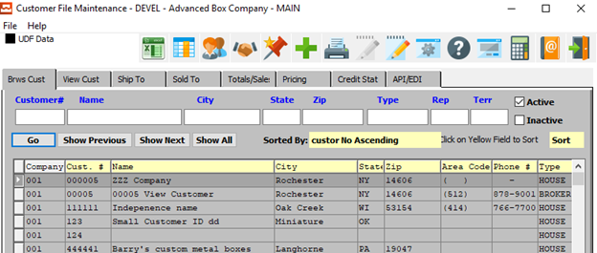

In order to view Ship-To information for a specific customer, the desired customer must be selected within the list of all available customers. The user may search for a specific customer, or narrow down the browse list, by using the search fields located along the top of the page.

In order to select a specific customer within the list to view detailed Ship-To information for, the user must ensure that it is highlighted within the list. In order to highlight a customer, the user may click on their desired customer.

## Ship-To Information

The user should then navigate to the *Ship-To* tab.

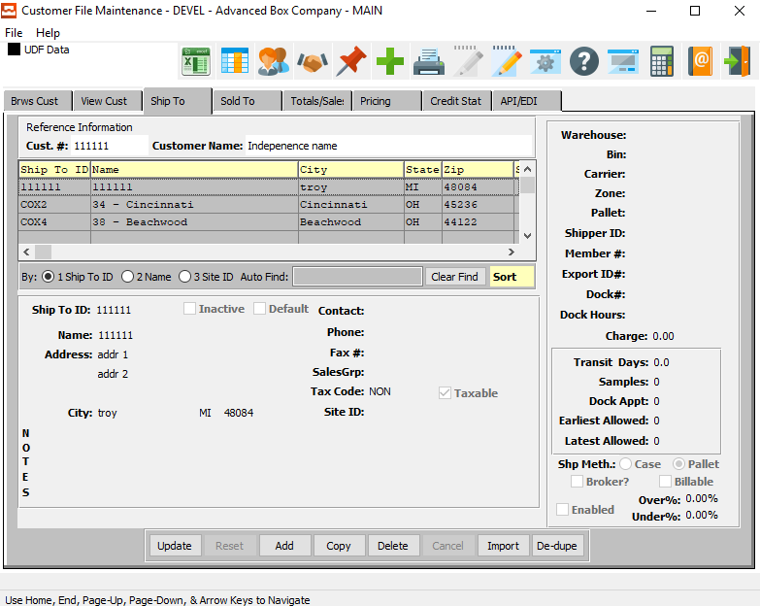

To view phone information for the selected customer, the user may now click on the ***“@ Pictured Address Book”*** at the top of the screen.

## Phone Information

### Browse Phone

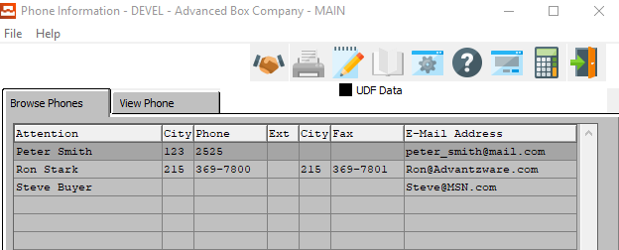

The Browse Phone screen will show the user all of the available contacts for the selected customer.

In order to view detailed information for a specific contact, the desired contact must be selected within the list of all available contacts. The user may search for a specific contact, or narrow down the browse list, by using the search field located at the bottom of the page.

In order to select a specific contact within the list to view detailed information for, the user must ensure that it is highlighted within the list. In order to highlight a contact, the user may click on their desired contact.

#### View Phone

Once the user has highlighted their desired contact to view detailed information for, they may click on the ***“View Phone”*** tab at the top of the screen. This tab allows the user to view detailed information, as well as update and add contacts.

### View Phone

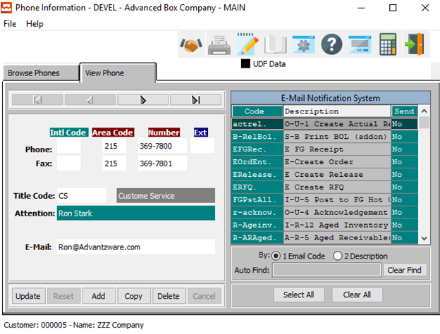

The ***“View Phone”*** screen shows the user detailed information about the selected Contact. In this screen, the user can update information about the current contact, update the current contact’s selected email notifications, or add a new contact.

#### UPDATE

Click the ***“Update”*** button to update the current Contact’s information.

#### ADD

Click the ***“Add”*** button to add a new Contact for this customer. If the user has chosen to ***“Add”*** a new Contact, the system will ask if the user wishes to import from the Customer Contact system.

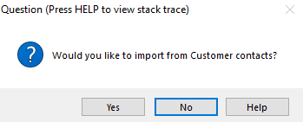

If the user chooses ***“Yes”***, the system will open the *“Customer Contacts Multi-Selector’* screen.

If the user chooses ***“No”***, the user will be allowed to manually enter all contact information into the screen.

#### COPY

Click the ***“Copy”*** button to copy information from the currently selected contact.

#### DELETE

Click the ***“Delete”*** button to delete the currently selected contact.

#### NEXT

Press ***"N"*** (Next) to find next Contact to view or modify. Alternatively, press the ***“Right Arrow”*** on the screen.

#### PREVIOUS

Press ***"P"*** (Previous) to find previous Contact to view or modify. Alternatively, press the ***“Left Arrow”*** on the screen.

### Add/Update Phone – Manual Input

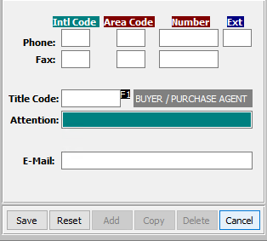

#### SAVE

Click the “***Save***” button to save the current Contact.

#### RESET

Click the “***Reset***” button to reset all changes to the Contact.

#### CANCEL

Click the “***Cancel***” button to cancel the Contact without saving changes.

### Add/Update Phone Field Definitions

#### International Code - Phone

Enter the International Code for this contact’s phone number.

#### Area Code - Phone

Enter the Area Code for this contact’s phone number.

#### Phone Number

Enter this contact’s phone number.

#### Phone Extension

Enter this contact’s phone extension code.

#### International Code – Fax

Enter the International Code for this contact’s fax number.

#### Area Code – Fax

Enter the Area Code for this contact’s fax number.

#### Fax Number

Enter this contact’s fax number.

#### Title Code

Enter this contact’s Title Code. Alternatively, the user can press the ***“F1”*** key to choose a Title Code from a list of available codes.

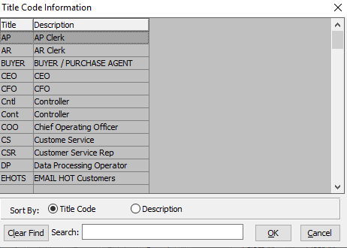

#### Attention

Enter the Contact’s Name.

#### E-Mail

Enter the e-mail address for this contact.

### Add/Update Phone – Import from Customer Contacts

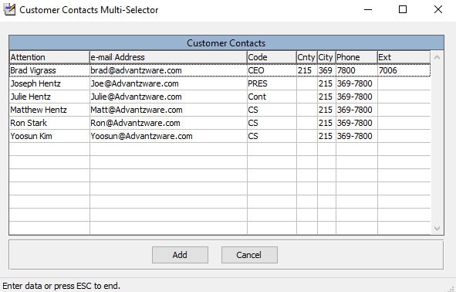

The user may choose a contact to add to this customer from a list of available contacts in the system. In order to select a specific contact to add, the user must ensure that it is highlighted within the list. In order to highlight a contact, the user may click on their desired contact.

#### ADD

Once the desired contact has been highlighted within the list, t he user may click the ***“Add”*** button to add the contact to the Customer list of contacts.

#### CANCEL

If the user does not see a contact that they wish to add, they may click the ***“Cancel”*** button cancel adding a new contact to the Customer Contact list.

## Email Notification System

### Email Notification System Options

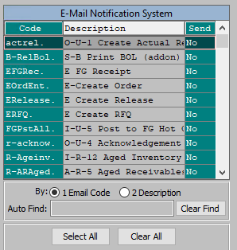

The *‘E-Mail Notification System’* allows the user to quickly choose which e-mails this Contact will receive from the Advantzware system. Contacts will only receive system emails that have their *“Send”* column set to ***“Yes”***.

In order to set the Contact up for a specific email notification, the user can search for their desired Email Code narrow down the browse list, by using the search field located at the bottom of the page.

In order to set a specific contact within the list to a ***“Yes”*** send option, the user must double-click the desired email code. This will set the email send option to ***“Yes”*** if it is currently ***“No”***, opting the Contact in for this specific email. Alternatively, double-clicking an email that currently has a send option of ***“Yes”*** will set it to ***“No”***, thus opting the contact out of receiving the selected email.

#### SELECT ALL

Clicking the ***“Select All”*** button will opt the user into receiving all the system emails currently available, setting all the Send Options to ***“Yes”***.

#### CLEAR ALL

Clicking the ***“Clear All”*** button will opt the user out of receiving all the system emails currently available, setting all the Send Options to ***“No”***.

### Add Contacts to Specific Ship-To Locations

This will automatically check the Bill of Lading option. Other programs will be available to invoke the email notice logic as we make the changes. However, this will be determined by the customer phone icon, not be ship to location.

## Add Contacts to ECODES File

Next step for bill of lading advanced notification is to add the specific contacts to the ECODES file under the bill of lading program.

The *Email Codes* screen is located in the Menu Path: Network/System Administrator -> Codes -> Email Codes. Alternatively, the user can quickly get to this screen using the Hot Key combination: ***[“N” – “C” – “1”]***.

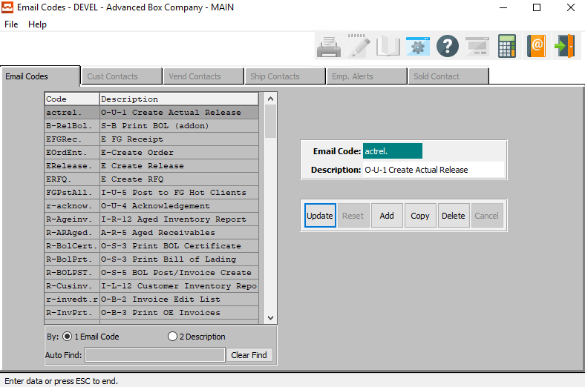

Then select the *Print Bill of Lading* program (*R-BolPrt)* and click the *Ship Contacts* tab.

### Customer Contacts

Please Note: The Customer Contacts may be used in combination with the output to email, however this will not work in batch mode or by ship to location. Hence, you could define a master contact for all bill of ladings, and specific contacts by ship to location.

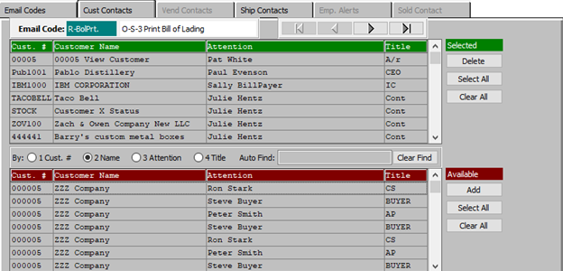

Adding contacts has many ways to search for specific customers or contacts by customer, title, name or attention.

#### DELETE (Selected)

To delete the currently selected Email Code, simply press the ***"D"*** key. Alternatively, click the ***“Delete”*** button at the bottom of the screen.

#### SELECT ALL (Selected)

Click the ***“Select All”*** button in the ‘*Selected’* section to highlight all Customer Contacts that are currently in the *‘Selected’* section. The user may use this for mass deletion of items within this section, as opposed to deleting contacts individually.

#### CLEAR ALL (Selected)

Click the ***“Clear All”*** button in the ‘*Selected’* section to un-highlight all Customer Contacts that are currently in the *‘Selected’* section.

#### ADD (Available)

Click on the selected contact from the ‘*Available’* list to highlight it, then click the ***“Add”*** button to add the selected column to the ‘*Selected’* list.

#### SELECT ALL (Available)

Click the ***“Select All”*** button in the ‘*Available’* section to highlight all Customer Contacts that are currently in the *‘Available’* section. The user may use this for mass deletion of all items within this section, as opposed to deleting contacts individually.

#### CLEAR ALL (Available)

Click the ***“Clear All”*** button in the ‘*Available’* section to un-highlight all Customer Contacts that are currently in the *‘Available’* section.

### Ship Contacts

Click the *Ship Contacts* tab to assign contacts to receive the advanced email notification when printing bill of ladings.

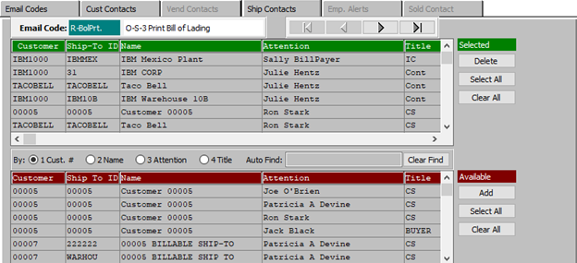

Once you find the contacts from the customer’s ship to file, click the ADD button and the contacts will transfer to the Green bar where selected contracts reside.

#### DELETE (Selected)

To delete the currently selected Ship Contact, simply press the ***"D"*** key. Alternatively, click the ***“Delete”*** button at the bottom of the screen.

#### SELECT ALL (Selected)

Click the ***“Select All”*** button in the ‘*Selected’* section to highlight all Ship Contacts that are currently in the *‘Selected’* section. The user may use this for mass deletion of items within this section, as opposed to deleting contacts individually.

#### CLEAR ALL (Selected)

Click the ***“Clear All”*** button in the ‘*Selected’* section to un-highlight all Ship Contacts that are currently in the *‘Selected’* section.

#### ADD (Available)

Click on the selected contact from the ‘*Available’* list to highlight it, then click the ***“Add”*** button to add the selected column to the ‘*Selected’* list.

#### SELECT ALL (Available)

Click the ***“Select All”*** button in the ‘*Available’* section to highlight all Ship Contacts that are currently in the *‘Available’* section. The user may use this for mass deletion of all items within this section, as opposed to deleting contacts individually.

#### CLEAR ALL (Available)

Click the ***“Clear All”*** button in the ‘*Available’* section to un-highlight all Ship Contacts that are currently in the *‘Available’* section.

## New Report Toggle Boxes

The *Print Bills of Lading* screen is located in the following Menu Path: Order Processing -> Shipping/Bill of Lading -> Print Bills of Lading. Alternatively, the user can quickly get to this screen using the Hot Key combination: ***[“O” – “S” – “3”]***.

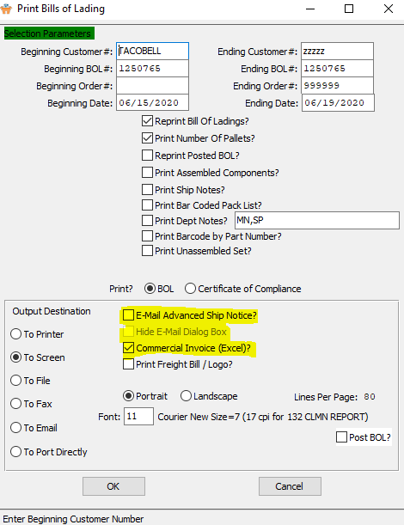

Please Note: If the user has chosen customers that have been added to this Email Code list, they will notice the new toggle boxes called “*Email Advanced Ship Notice”*, “*Hide Email Dialog Box”* and “*Commercial Invoice (Excel)*”.

The *Commercial Invoice* option will display the business form as if the output was going to the screen. When the *Hide Email* option is checked, the email dialog box which displays the Send-To and Subject Topic will run in background.

When unchecked, the user must click the ***“Send”*** button for each email ship to location.

Once you click the ***“OK”*** button, the system will process all the bill of ladings. This process will batch the bill of ladings into one singe .PDF format indicating the range of bill of ladings in the text message section of the email.

Notice, the system automatically selected the ship to contacts for this ship to location.

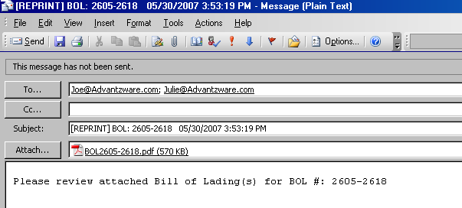

### Preview Form

Finally, if the user has checked the option to preview the form, the document is displayed prior to creating the email.

Please Note: This button is not needed if the user has not clicked the “*Hide Email Dialog Box”*, because they can view the attachment prior to sending the email.

The user will notice the attachment has combined all the bill of ladings for this ship to location into one single attachment. The page numbers listed at the bottom indicate the total number of bill of ladings. Each click of the ***“Arrow Key”*** at the bottom will display a different bill of lading for this specific ship to location.

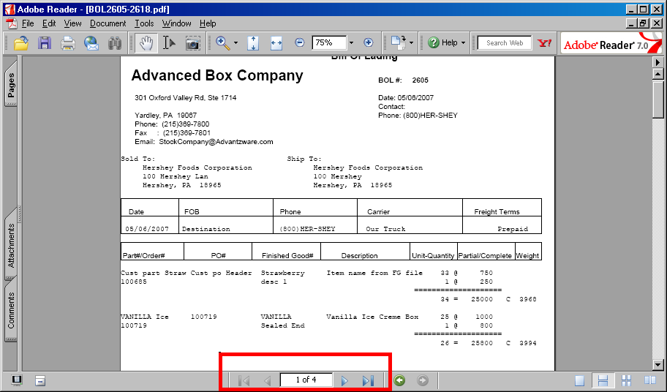

# **Invoice Print and Email Options**

## Customer File Maintenance [AF1]

First, contacts must be added for each ship to location in the customer file.

The *Customer File Maintenance* screen is located in the following Menu Path: Accounts Receivable -> File Maintenance for Customers -> Customers. Alternatively, the user can quickly get to this screen using the Hot Key combination: ***[“A” – “F” – “1”]***.

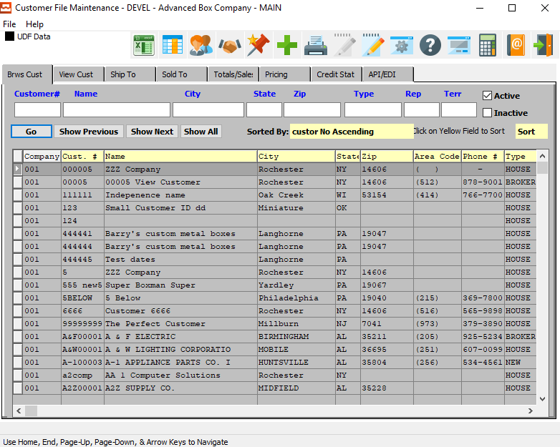

In order to view Ship-To information for a specific customer, the desired customer must be selected within the list of all available customers. The user may search for a specific customer, or narrow down the browse list, by using the search fields located along the top of the page.

In order to select a specific customer within the list to view detailed Ship-To information for, the user must ensure that it is highlighted within the list. In order to highlight a customer, the user may click on their desired customer.

## View Customer Information

The user should then navigate to the *View Customer* tab.

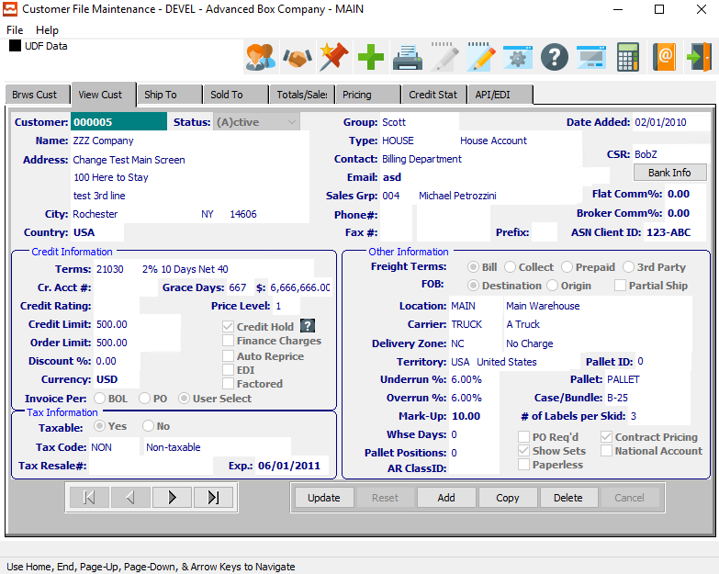

### Paperless Invoicing and Invoices for Postage by Mail Only

The *Paperless* toggle box located within the *Other Information* section works in conjunction with the Invoice Printing options in order processing. When this is checked, the program will only allow output to email.

When output to a printer, invoice for this customer will not print thus saving the cost of paper as well as the cost of postage and labor stuffing the envelopes. When this is unchecked, then output to printer is allowed.

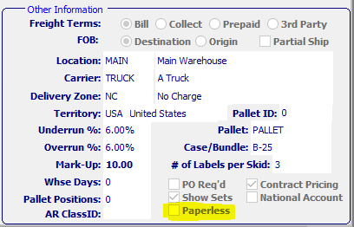

## Invoice Maintenance

The *Invoice Maintenance* screen is located in the following Menu Path: Order Processing -> Billing/Counter Sales -> Enter/Edit Invoices. Alternatively, the user can quickly get to this screen using the Hot Key combination: ***[“O” – “B” – “1”]***.

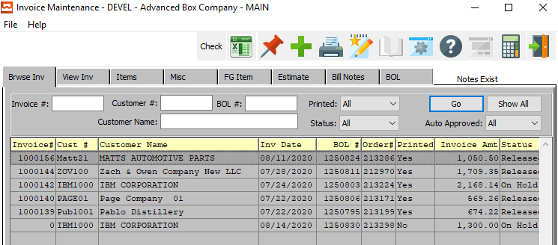

The user should then navigate to the *View Invoice* tab. Then, press the ***“Printer”*** icon at the top of the screen in order to bring up the *Print Invoice List – Invoicing* screen.

### Invoicing Screen

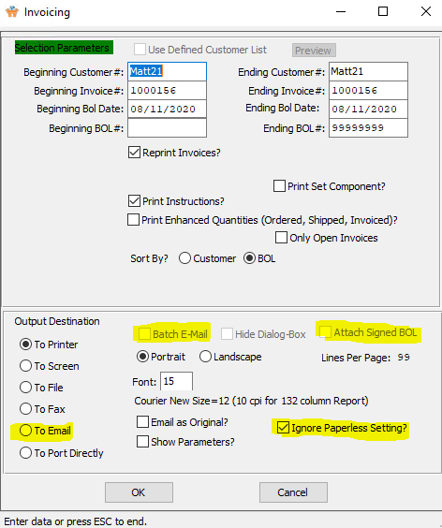

Any customer’s invoice can be emailed by clicking the *“Batch E-Mail”* toggle box regardless of the customer field setting for Paperless Invoice. However, when clicking the *“Batch E-Mail”* option, only customers set to *Paperless Invoice* will be emailed in the batch range of customer invoices selected. Customer not defined as paperless invoice will be bypassed when batch emailing.

The *Paperless Invoice* toggle box works in conjunction with the Invoice Printing options in order processing. When this is checked, the program will only allow output to email. When output to a printer, invoices for this customer will not print thus saving the cost of paper as well as the cost of postage and labor stuffing the envelopes.

When this is unchecked, then output to customer invoice will print only for customers that want mailed invoices. Please note, all options can be overwritten by clicking the toggle box *“Ignore Paperless Setting?”*. Meaning, we can still print invoices for paperless clients and email mail only clients.

### Email Contacts for Invoicing

Once the user clicks the ***“OK”*** button to email or batch email the invoice, all customers set to paperless invoice will automatically be emailed.

In the sample email below, in RED is the contacts that were automatically transferred to the *SENT TO* window. The invoice form is automatically converted into a .PDF file that can be easily read by a customer.

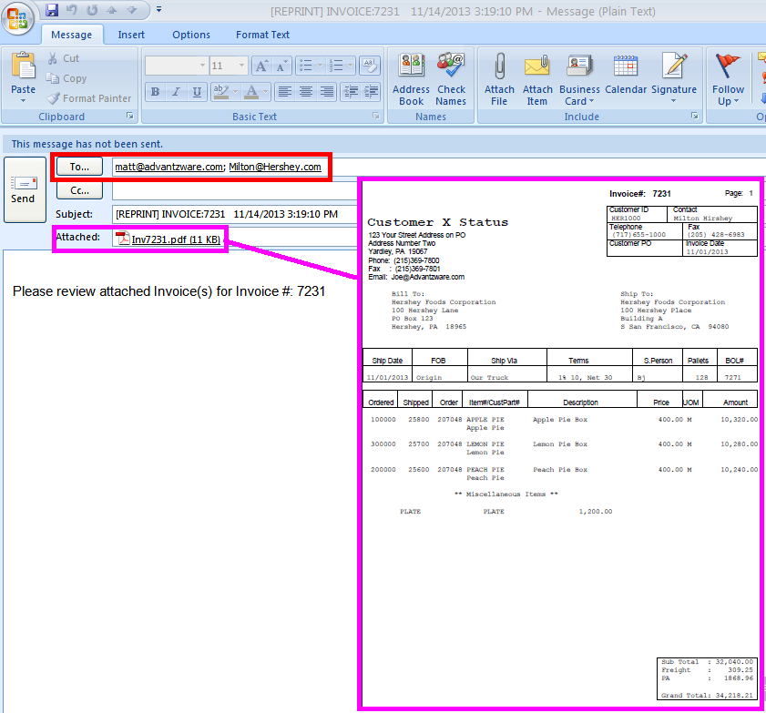

In addition, if the user has checked the toggle box to include a signed bill of lading, another attachment will be added for the signed bill of lading from. The “*Hide”* Toggle Box will hide this Microsoft email display in background and process one customer after another until the entire batch is completed.

The entire process will require no manual intervention. Of course, if there are invalid emails or no contact defined for a customer, the program will either skip that customer or may pause until you select a contract to be emailed.

### Customer File Maintenance

The Advantzware email notification logic allows a business to maintain a company- wide email database that works in conjunction with Microsoft Outlook. Instead of each employee maintaining their own Microsoft Address Book, the company can now house the key contacts by customer.

The email contacts for invoicing must be setup so that batch emailing invoices can transfer the *SEND TO* Contacts to the email for each invoice. First, contacts must be added for each customer in the customer file via the phone icon.

Define unlimited contacts for each department so that you effortlessly email invoices, quotes, advanced ship notices, statements, inventory reports and much more.

The *Customer File Maintenance* screen is located in the following Menu Path: Accounts Receivable -> File Maintenance for Customers -> Customers. Alternatively, the user can quickly get to this screen using the Hot Key combination: ***[“A” – “F” – “1”]***.

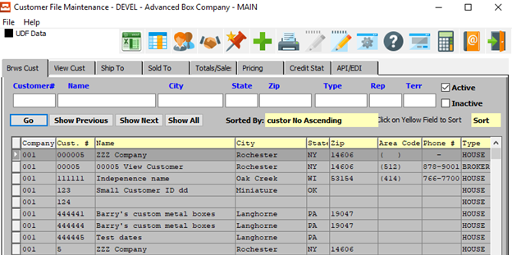

In order to view contact information for a specific customer, the desired customer must be selected within the list of all available customers. The user may search for a specific customer, or narrow down the browse list, by using the search fields located along the top of the page.

In order to select a specific customer within the list to view detailed Ship-To information for, the user must ensure that it is highlighted within the list. In order to highlight a customer, the user may click on their desired customer.

To view phone information for the selected customer, the user may now click on the ***“@ Pictured Address Book”*** at the top of the screen.

### Browse Phone



The Browse Phone screen will show the user all of the available contacts for the selected customer.

In order to view detailed information for a specific contact, the desired contact must be selected within the list of all available contacts. The user may search for a specific contact, or narrow down the browse list, by using the search field located at the bottom of the page.

In order to select a specific contact within the list to view detailed information for, the user must ensure that it is highlighted within the list. In order to highlight a contact, the user may click on their desired contact.

#### View Phone

Once the user has highlighted their desired contact to view detailed information for, they may click on the ***“View Phone”*** tab at the top of the screen. This tab allows the user to view detailed information, as well as update and add contacts.

### Email Invoices



The *‘E-Mail Notification System’* allows the user to quickly choose which e-mails this Contact will receive from the Advantzware system. Contacts will only receive system emails that have their *“Send”* column set to ***“Yes”***.

In order to set the Contact up for a specific email notification, the user can search for their desired Email Code narrow down the browse list, by using the search field located at the bottom of the page.

In order to set a specific contact within the list to a ***“Yes”*** send option, the user must double-click the desired email code. This will set the email send option to ***“Yes”*** if it is currently ***“No”***, opting the Contact in for this specific email. Alternatively, double-clicking an email that currently has a send option of ***“Yes”*** will set it to ***“No”***, thus opting the contact out of receiving the selected email.

#### SELECT ALL

Clicking the ***“Select All”*** button will opt the user into receiving all the system emails currently available, setting all the Send Options to ***“Yes”***.

#### CLEAR ALL

Clicking the ***“Clear All”*** button will opt the user out of receiving all the system emails currently available, setting all the Send Options to ***“No”***.

#### R-InvPrint

To email invoices, the program R-InvPrint must be set to ***“Yes”*** for as many contacts desired that you want to receive the invoice. So set up the controller, purchasing agent, sales rep and account payable clerk to receive your invoice simultaneously.

This provides a great marketing and customer service tool that allows each department to keep track of detailed conversations by date and topic. Sales calls, collection calls, plant directions, personal notes, company notes, quote history notes and unlimited topics can be saved by contact.

## ECODES for Email Contacts for Invoicing

Once contacts are added to the customer and each contact has valid email address, the Email codes file will be automatically updated for each file. The entire list of contacts by customer by program can be view on the Email Codes file. You can ***“Add”*** or ***“Delete”*** contacts to any email program under the ECODES file. You can add by title to speed the data entry process.

The *Email Codes* screen is located in the Menu Path: Network/System Administrator -> Codes -> Email Codes. Alternatively, the user can quickly get to this screen using the Hot Key combination: ***[“N” – “C” – “1”]***.



Then select the *Print OE Invoices* program (*R-InvPrt)* and click the *Sold Contacts* tab.

### Customer Contacts

All the *Available* contacts added to the customers phone contacts are listed on the bottom window.

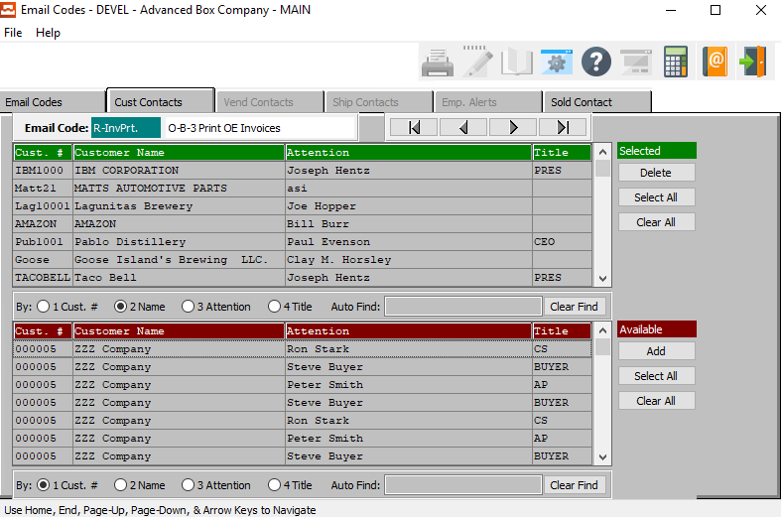

#### DELETE (Selected)

To delete the currently selected Email Code, simply press the ***"D"*** key. Alternatively, click the ***“Delete”*** button at the bottom of the screen.

#### SELECT ALL (Selected)

Click the ***“Select All”*** button in the ‘*Selected’* section to highlight all Customer Contacts that are currently in the *‘Selected’* section. The user may use this for mass deletion of items within this section, as opposed to deleting contacts individually.

#### CLEAR ALL (Selected)

Click the ***“Clear All”*** button in the ‘*Selected’* section to un-highlight all Customer Contacts that are currently in the *‘Selected’* section.

#### ADD (Available)

Click on the selected contact from the ‘*Available’* list to highlight it, then click the ***“Add”*** button to add the selected column to the ‘*Selected’* list.

#### SELECT ALL (Available)

Click the ***“Select All”*** button in the ‘*Available’* section to highlight all Customer Contacts that are currently in the *‘Available’* section. The user may use this for mass deletion of all items within this section, as opposed to deleting contacts individually.

#### CLEAR ALL (Available)

Click the ***“Clear All”*** button in the ‘*Available’* section to un-highlight all Customer Contacts that are currently in the *‘Available’* section.

### Sold Contacts

The user can select any specific contact, or all contact by customer or by Title, then once selected you click the ADD Button to move the contacts to the Program. All contacts set to receive invoices via email are in the top window.

Contacts can be deleted simply by selecting a contact or a range of contacts by customer or title, the clicking the ***“Delete”*** Button.

Please Note: This is the same file that can be updated when selecting the email program for a contact in the customer files, phone Icon table.

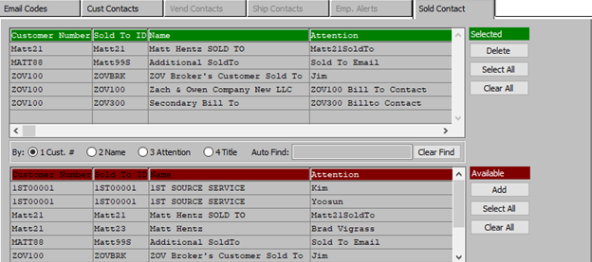

#### DELETE (Selected)

To delete the currently selected Ship Contact, simply press the ***"D"*** key. Alternatively, click the ***“Delete”*** button at the bottom of the screen.

#### SELECT ALL (Selected)

Click the ***“Select All”*** button in the ‘*Selected’* section to highlight all Ship Contacts that are currently in the *‘Selected’* section. The user may use this for mass deletion of items within this section, as opposed to deleting contacts individually.

#### CLEAR ALL (Selected)

Click the ***“Clear All”*** button in the ‘*Selected’* section to un-highlight all Ship Contacts that are currently in the *‘Selected’* section.

#### ADD (Available)

Click on the selected contact from the ‘*Available’* list to highlight it, then click the ***“Add”*** button to add the selected column to the ‘*Selected’* list.

#### SELECT ALL (Available)

Click the ***“Select All”*** button in the ‘*Available’* section to highlight all Ship Contacts that are currently in the *‘Available’* section. The user may use this for mass deletion of all items within this section, as opposed to deleting contacts individually.

#### CLEAR ALL (Available)

Click the ***“Clear All”*** button in the ‘*Available’* section to un-highlight all Ship Contacts that are currently in the *‘Available’* section.

## Scanning and Saving Signed Bill of Ladings

### N-K-1 BOLSIGN

The user must now make sure that all parameters in the ***“N” – “K” – “1”*** ***BOLSIGN*** program are set up correctly.

The *System Control Parameters Maintenance* screen is located in the following Menu Path: Network/System Administrator -> K-Control Parameters -> System Control Parameters. Alternatively, the user can quickly get to this screen using the Hot Key combination: ***[“N” – “K” – “1”]***.

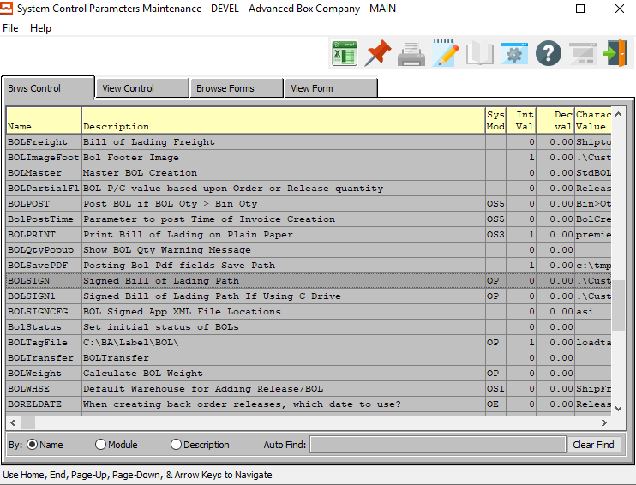

The *“Browse Control”* screen will show the user all of the available Control Parameters for the selected program.

In order to view detailed information for a specific Control Program, the desired program must be selected within the list of all available programs. The user may search for a specific Control Program, or narrow down the browse list, by using the search field located at the bottom of the page.

In order to select a specific Control Program within the list to view detailed information for, the user must ensure that it is highlighted within the list. In order to highlight the desired Control Program, the user may click on their desired program.

#### BOLSIGN

For this specific issue, the user must choose the ***BOLSIGN*** program.

#### View Control

Once the user has highlighted their desired Control Program to view detailed information for, they may click on the ***“View Program”*** tab at the top of the screen. This tab allows the user to view detailed information, as well as update program parameters.

### Control Parameters

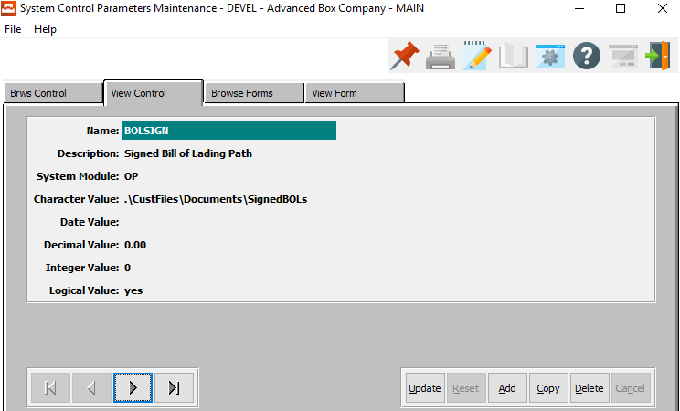

#### Character Value

Enter the location where you save the scanned bill of lading files. You must create a folder on your network drive to house the Signed Bill of Lading. Right Mouse Click on the Start Button on the Bottom Left and Add this Folder.

#### Logical Value

Setting the *Logical Value* to ***“Yes”*** will allow the user to scan a signed copy of a Bill of Lading and attach the .Jpg or .Bmt file to the posted BOL. The scanned BOL must be saved as the file name = BOL#. The User will scan BOL document and save the file using the posted BOL number.

The “***O”-“Q”-“1”***, looks up the order, clicks on the "*Invoice*" tab, and in the window that comes up, clicks on "*BOL*" tab. The will now be a new Button called "***Signed BOL***". This will view / print the Jpeg. Scanned BOLs will be saved as JPEG files with filenames "bol_number.jpg" (for example, 82703.jpg), in the directory that is set under “***N”-“K”-“1” BOLSIGN*** Character value. If file "bol_number.jpg" does not exist, the "SIGNED BOL button will be Disabled, and clicking the button would Prompt "Signed receipt Unavailable".

#### Outcome

When Bill of Lading are returned to your office with a signature, someone must Scan each bill of lading and Save them with the BOL number as the File Name. Each BOL must be saved in the folder assigned to the character Value Below.

# **Emailing Purchase Orders**

## Vendor File

When printing a purchase order, the Advantzware Software has an option to ***“Output to Email”***.  
This will convert our business forms created with the XPRINT software into a .PDF format that can be read from any computer that hour customer may own. However, you can save much more time by having the EMAIL automatically import the contacts to the *SEND TO* section of the email.

The Vendor File allows unlimited contacts via the ***“Phone Address Book”*** icon. Each contact may have unlimited notes via the Fountain Pen Icon. Each contact will have a title, phone number and email address.

The *Vendors* screen is located in the following Menu Path: Vouchers/Payables -> File Maintenance for Vendors -> Vendors. Alternatively, the user can quickly get to this screen using the Hot Key combination: ***[“V” – “F” – “1”]***.

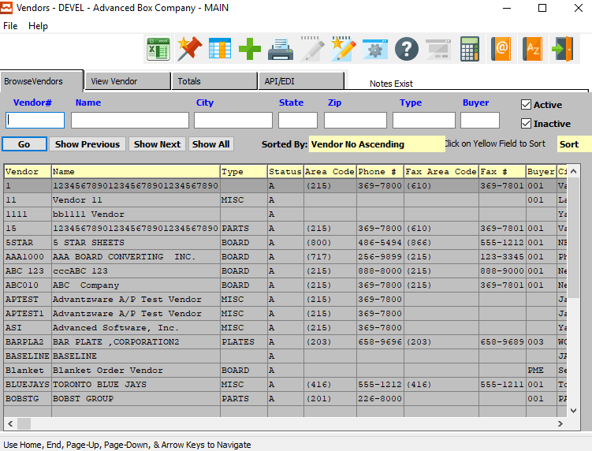

In order to view contact information for a specific Vendor, the desired Vendor must be selected within the list of all available Vendors. The user may search for a specific Vendor, or narrow down the browse list, by using the search fields located along the top of the page.

In order to select a specific Vendor within the list to view detailed contact information for, the user must ensure that it is highlighted within the list. In order to highlight a Vendor, the user may click on their desired Vendor.

## Phone Information

### Browse Phone



The Browse Phone screen will show the user all of the available contacts for the selected customer.

In order to view detailed information for a specific contact, the desired contact must be selected within the list of all available contacts. The user may search for a specific contact, or narrow down the browse list, by using the search field located at the bottom of the page.

In order to select a specific contact within the list to view detailed information for, the user must ensure that it is highlighted within the list. In order to highlight a contact, the user may click on their desired contact.

#### View Phone

Once the user has highlighted their desired contact to view detailed information for, they may click on the ***“View Phone”*** tab at the top of the screen. This tab allows the user to view detailed information, as well as update and add contacts.

### View Phone



The ***“View Phone”*** screen shows the user detailed information about the selected Contact. In this screen, the user can update information about the current contact, update the current contact’s selected email notifications, or add a new contact.

#### UPDATE

Click the ***“Update”*** button to update the current Contact’s information.

#### ADD

Click the ***“Add”*** button to add a new Contact for this customer. If the user has chosen to ***“Add”*** a new Contact, the system will ask if the user wishes to import from the Customer Contact system.



If the user chooses ***“Yes”***, the system will open the *“Customer Contacts Multi-Selector’* screen.

If the user chooses ***“No”***, the user will be allowed to manually enter all contact information into the screen.

#### COPY

Click the ***“Copy”*** button to copy information from the currently selected contact.

#### DELETE

Click the ***“Delete”*** button to delete the currently selected contact.

#### NEXT

Press ***"N"*** (Next) to find next Contact to view or modify. Alternatively, press the ***“Right Arrow”*** on the screen.

#### PREVIOUS

Press ***"P"*** (Previous) to find previous Contact to view or modify. Alternatively, press the ***“Left Arrow”*** on the screen.

### Add/Update Phone – Manual Input



#### SAVE

Click the “***Save***” button to save the current Contact.

#### RESET

Click the “***Reset***” button to reset all changes to the Contact.

#### CANCEL

Click the “***Cancel***” button to cancel the Contact without saving changes.

### Add/Update Phone Field Definitions

#### International Code - Phone

Enter the International Code for this contact’s phone number.

#### Area Code - Phone

Enter the Area Code for this contact’s phone number.

#### Phone Number

Enter this contact’s phone number.

#### Phone Extension

Enter this contact’s phone extension code.

#### International Code – Fax

Enter the International Code for this contact’s fax number.

#### Area Code – Fax

Enter the Area Code for this contact’s fax number.

#### Fax Number

Enter this contact’s fax number.

#### Title Code

Enter this contact’s Title Code. Alternatively, the user can press the ***“F1”*** key to choose a Title Code from a list of available codes.



#### Attention

Enter the Contact’s Name.

#### E-Mail

Enter the e-mail address for this contact.

### Add/Update Phone – Import from Customer Contacts



The user may choose a contact to add to this customer from a list of available contacts in the system. In order to select a specific contact to add, the user must ensure that it is highlighted within the list. In order to highlight a contact, the user may click on their desired contact.

#### ADD

Once the desired contact has been highlighted within the list, t he user may click the ***“Add”*** button to add the contact to the Customer list of contacts.

#### CANCEL

If the user does not see a contact that they wish to add, they may click the ***“Cancel”*** button cancel adding a new contact to the Customer Contact list.

## Email Notification System

### Email Notification System Options



The *‘E-Mail Notification System’* allows the user to quickly choose which e-mails this Contact will receive from the Advantzware system. Contacts will only receive system emails that have their *“Send”* column set to ***“Yes”***.

In order to set the Contact up for a specific email notification, the user can search for their desired Email Code narrow down the browse list, by using the search field located at the bottom of the page.

In order to set a specific contact within the list to a ***“Yes”*** send option, the user must double-click the desired email code. This will set the email send option to ***“Yes”*** if it is currently ***“No”***, opting the Contact in for this specific email. Alternatively, double-clicking an email that currently has a send option of ***“Yes”*** will set it to ***“No”***, thus opting the contact out of receiving the selected email.

#### SELECT ALL

Clicking the ***“Select All”*** button will opt the user into receiving all the system emails currently available, setting all the Send Options to ***“Yes”***.

#### CLEAR ALL

Clicking the ***“Clear All”*** button will opt the user out of receiving all the system emails currently available, setting all the Send Options to ***“No”***.

### Add Contacts to Purchase Order Emails

The program to print the purchase order must be checked with the word ***“Yes”***. When printing and email, the user must click the *OUTPUT TO: EMAIL* option. Once check, the Advantzware software will generate a Purchase Order Form via the XPRINT software and simultaneously convert this business form into a .PDF format as an attachment to the email.

The *SEND* TO: section of the email will then simultaneously import the contacts from the Vendor Contacts. No matter, who emails the purchase order within your company, the proper contacts will be sent the email.

Please Note: This does not require the name to be setup in anyone’s Address Book in Microsoft Outlook. Each contact must be setup in the same manner .

## ECODES

The ECODE files is an alternative method to setting up automatic contacts for emailing compared to the vendor file. This provides the ability to quickly define many companies at one time, whereas the Vendor File is on vendor and one contact at a time.

Each contact must still be defined in the Vendor file with a title code and email address. At the top of the Main Menu, click the Codes button, then click the Email Codes Menu Option.

The ECODES program will be listed showing the Advantzware Menu keys that are used to generate the contact list to be emailed. Below the purchase order program has been selected so that contacts by company can be assigned.

The *Email Codes* screen is located in the Menu Path: Network/System Administrator -> Codes -> Email Codes. Alternatively, the user can quickly get to this screen using the Hot Key combination: ***[“N” – “C” – “1”]***.



Then select the *Print Purchase Orders* program (*R-POPrt)* and click the *Vend Contacts* tab.

### Vend Contacts

Click the *Vendor Contacts* tab to select contacts for emailing a purchase order.

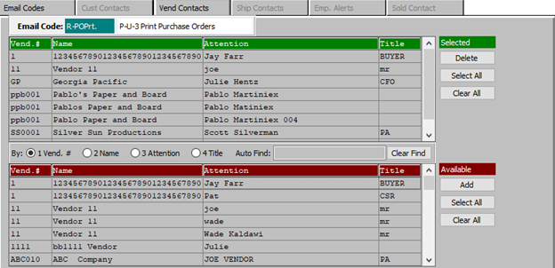

The *Top* window shows the contacts that have already been defined and are all set. The *Bottom* window is the entire list of all the contacts defined in the Advantzware contacts system.

The Vendor File was used to defined Sally Jones, John Adams and John Thomas for International Paper.  
Alternatively, we could sort the Advantzware contacts by Company, Vendor, Title or Contact.

#### DELETE (Selected)

To delete the currently selected Ship Contact, simply press the ***"D"*** key. Alternatively, click the ***“Delete”*** button at the bottom of the screen.

#### SELECT ALL (Selected)

Click the ***“Select All”*** button in the ‘*Selected’* section to highlight all Ship Contacts that are currently in the *‘Selected’* section. The user may use this for mass deletion of items within this section, as opposed to deleting contacts individually.

#### CLEAR ALL (Selected)

Click the ***“Clear All”*** button in the ‘*Selected’* section to un-highlight all Ship Contacts that are currently in the *‘Selected’* section.

#### ADD (Available)

Click on the selected contact from the ‘*Available’* list to highlight it, then click the ***“Add”*** button to add the selected column to the ‘*Selected’* list.

#### SELECT ALL (Available)

Click the ***“Select All”*** button in the ‘*Available’* section to highlight all Ship Contacts that are currently in the *‘Available’* section. The user may use this for mass deletion of all items within this section, as opposed to deleting contacts individually.

#### CLEAR ALL (Available)

Click the ***“Clear All”*** button in the ‘*Available’* section to un-highlight all Ship Contacts that are currently in the *‘Available’* section.

## Printing Purchase Orders

The *Print Purchase Orders* screen is located in the following Menu Path: Purchasing -> Update/Enter Purchase Orders -> Print PO’s. Alternatively, the user can quickly get to this screen using the Hot Key combination: ***[“P” – “U” – “3”]***.

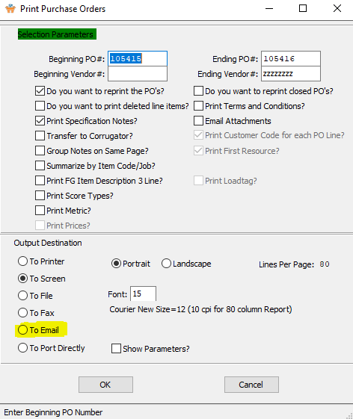

When printing and emailing, the user must click the *To Email* option in the “Output Destination” section. Once checked, the Advantzware software will generate a Purchase Order Form via the XPRINT software and simultaneously convert this business form into a .PDF format as an attachment to the email.

The SEND TO: section of the email will then simultaneously import the contacts from the Vendor contact information. No matter, who emails the purchase order within your company, the proper contacts will be sent the email.

Please Note: This does not require the name to be setup in anyone’s Address Book in Microsoft Outlook.

The Net Result to Setting up the contacts, is the names will appear on the SEND TO:   
section of the email. As you can see the purchase order form is converted to a .PDF format that can easily be read by any computer.

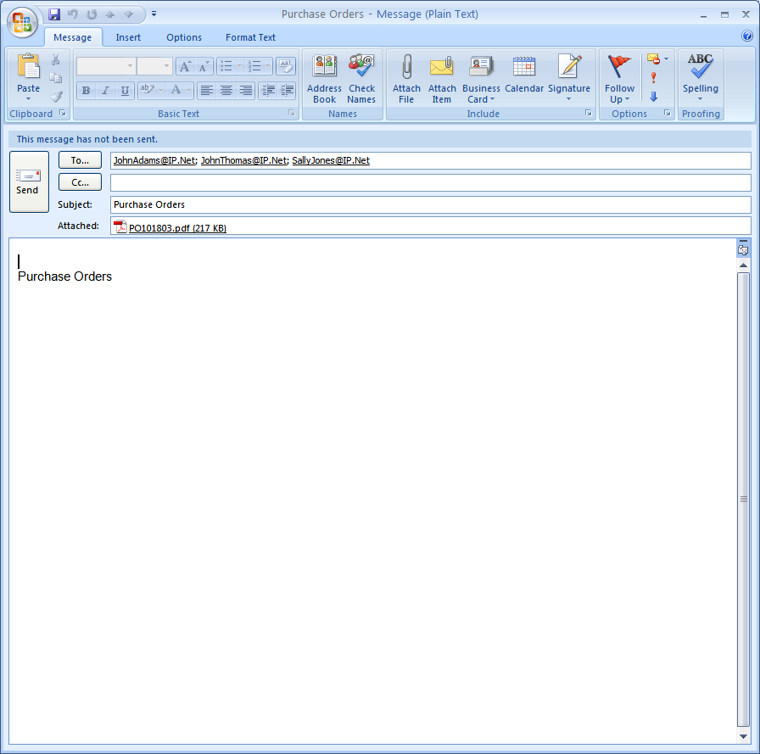

# **Emailing Finished Good Reorder Advice Alerts**

## Emailing Reorder Alert Emails for Finished Goods

### N-K-1 FGREORDER

The user must now make sure that all parameters in the ***“N” – “K” – “1”*** ***FGREORDER*** program are set up correctly.

The *System Control Parameters Maintenance* screen is located in the following Menu Path: Network/System Administrator -> K-Control Parameters -> System Control Parameters. Alternatively, the user can quickly get to this screen using the Hot Key combination: ***[“N” – “K” – “1”]***.



The *“Browse Control”* screen will show the user all of the available Control Parameters for the selected program.

In order to view detailed information for a specific Control Program, the desired program must be selected within the list of all available programs. The user may search for a specific Control Program, or narrow down the browse list, by using the search field located at the bottom of the page.

In order to select a specific Control Program within the list to view detailed information for, the user must ensure that it is highlighted within the list. In order to highlight the desired Control Program, the user may click on their desired program.

#### FGREORDER

For this specific issue, the user must choose the ***FGREORDER*** program.

#### View Control

Once the user has highlighted their desired Control Program to view detailed information for, they may click on the ***“View Program”*** tab at the top of the screen. This tab allows the user to view detailed information, as well as update program parameters.

### Control Parameters

The “***N”-“K”-“1” FGREORDER*** parameter is used to automatically create email alerts for finished goods items that fall below their reorder level. When posting a bill of lading, the software calculates the items available quantity to compare its reorder level and any item that is below this level will automatically create email to clients and/or to employees.

The finished goods item must be set up as a reorder advice item, emails contacts must be created for customers and/or email contacts must be created for employees. Your company will save much more time by having the EMAIL automatically import the contacts to the SEND TO section of the email.

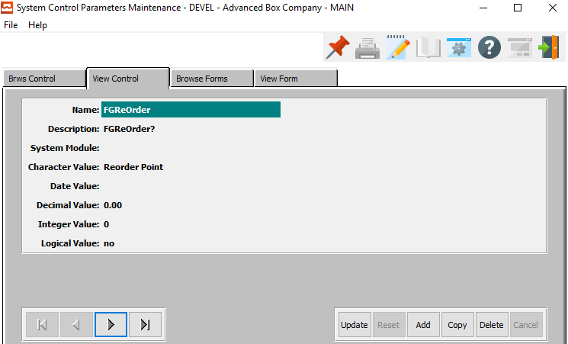

#### Character Value

Character Value = Reorder Point

#### Logical Value

Logical Value = YES to invoke this logic.

## Finished Goods File Maintenance

Only finished goods defined properly will generate email alerts. The item must be defined as a stocked item and he reorder policy radio button must be set to Reorder Point. The item may be manufactured or purchased whereby jobs and purchase orders will increase the on-order quantity. Finished goods receipts will simultaneously increase the on-hand quantity and decrease the on-order quantity.

The *Finished Goods Item Inventory* screen is located in the Menu Path: Inventory/Finished Goods -> File Maintenance for Items -> Finished Good Item. Alternatively, the user can quickly get to this screen using the Hot Key combination: ***[“I” – “F” – “1”]***.

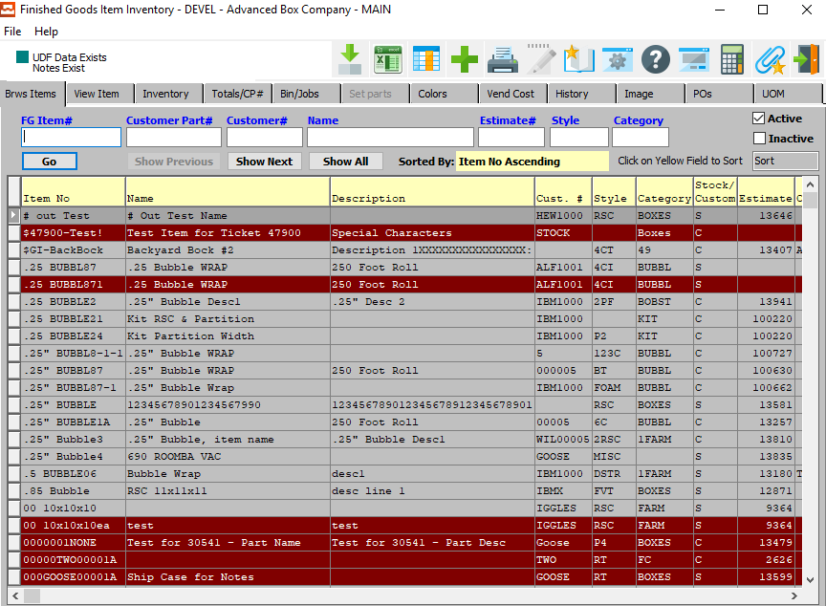

### Inventory Tab

Once the user has highlighted their desired Finished Good Item to view detailed information for, they may click on the ***“Inventory”*** tab at the top of the screen. This tab allows the user to view detailed information, as well as update and add inventory.

Adding customer orders will increase the quantity allocated or reserved. When shipping inventory via the bill of lading, the program simultaneously decreases the on hand and allocated quantities. The quantity available to sell to new customers is calculated a on hand plus on order less allocated.

When the quantity available is below the reorder level, the item must be replenished, and the bill of lading posting program will automatically generate an email.

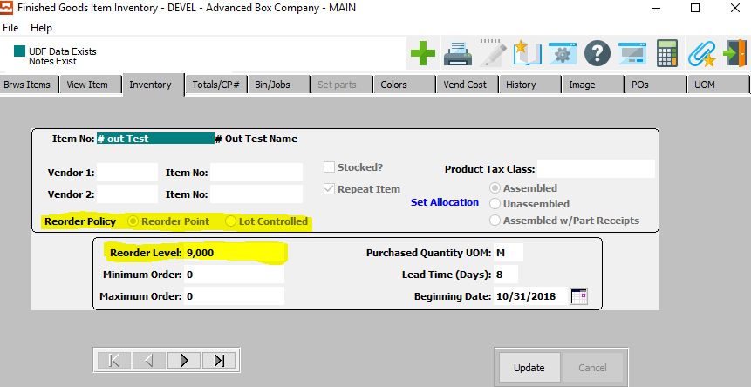

## Customer Phone Icon

### Browse Phone



The Browse Phone screen will show the user all of the available contacts for the selected customer.

In order to view detailed information for a specific contact, the desired contact must be selected within the list of all available contacts. The user may search for a specific contact, or narrow down the browse list, by using the search field located at the bottom of the page.

In order to select a specific contact within the list to view detailed information for, the user must ensure that it is highlighted within the list. In order to highlight a contact, the user may click on their desired contact.

#### View Phone

Once the user has highlighted their desired contact to view detailed information for, they may click on the ***“View Phone”*** tab at the top of the screen. This tab allows the user to view detailed information, as well as update and add contacts.

### View Phone



The ***“View Phone”*** screen shows the user detailed information about the selected Contact. In this screen, the user can update information about the current contact, update the current contact’s selected email notifications, or add a new contact.

#### UPDATE

Click the ***“Update”*** button to update the current Contact’s information.

#### ADD

Click the ***“Add”*** button to add a new Contact for this customer. If the user has chosen to ***“Add”*** a new Contact, the system will ask if the user wishes to import from the Customer Contact system.



If the user chooses ***“Yes”***, the system will open the *“Customer Contacts Multi-Selector’* screen.

If the user chooses ***“No”***, the user will be allowed to manually enter all contact information into the screen.

#### COPY

Click the ***“Copy”*** button to copy information from the currently selected contact.

#### DELETE

Click the ***“Delete”*** button to delete the currently selected contact.

#### NEXT

Press ***"N"*** (Next) to find next Contact to view or modify. Alternatively, press the ***“Right Arrow”*** on the screen.

#### PREVIOUS

Press ***"P"*** (Previous) to find previous Contact to view or modify. Alternatively, press the ***“Left Arrow”*** on the screen.

### Add/Update Phone – Manual Input



#### SAVE

Click the “***Save***” button to save the current Contact.

#### RESET

Click the “***Reset***” button to reset all changes to the Contact.

#### CANCEL

Click the “***Cancel***” button to cancel the Contact without saving changes.

### Add/Update Phone Field Definitions

#### International Code - Phone

Enter the International Code for this contact’s phone number.

#### Area Code - Phone

Enter the Area Code for this contact’s phone number.

#### Phone Number

Enter this contact’s phone number.

#### Phone Extension

Enter this contact’s phone extension code.

#### International Code – Fax

Enter the International Code for this contact’s fax number.

#### Area Code – Fax

Enter the Area Code for this contact’s fax number.

#### Fax Number

Enter this contact’s fax number.

#### Title Code

Enter this contact’s Title Code. Alternatively, the user can press the ***“F1”*** key to choose a Title Code from a list of available codes.



#### Attention

Enter the Contact’s Name.

#### E-Mail

Enter the e-mail address for this contact.

### Add/Update Phone – Import from Customer Contacts



The user may choose a contact to add to this customer from a list of available contacts in the system. In order to select a specific contact to add, the user must ensure that it is highlighted within the list. In order to highlight a contact, the user may click on their desired contact.

#### ADD

Once the desired contact has been highlighted within the list, t he user may click the ***“Add”*** button to add the contact to the Customer list of contacts.

#### CANCEL

If the user does not see a contact that they wish to add, they may click the ***“Cancel”*** button cancel adding a new contact to the Customer Contact list.

## Customer Employee Contacts

### Email Notification System Options



The *‘E-Mail Notification System’* allows the user to quickly choose which e-mails this Contact will receive from the Advantzware system. Contacts will only receive system emails that have their *“Send”* column set to ***“Yes”***.

In order to set the Contact up for a specific email notification, the user can search for their desired Email Code narrow down the browse list, by using the search field located at the bottom of the page.

In order to set a specific contact within the list to a ***“Yes”*** send option, the user must double-click the desired email code. This will set the email send option to ***“Yes”*** if it is currently ***“No”***, opting the Contact in for this specific email. Alternatively, double-clicking an email that currently has a send option of ***“Yes”*** will set it to ***“No”***, thus opting the contact out of receiving the selected email.

#### SELECT ALL

Clicking the ***“Select All”*** button will opt the user into receiving all the system emails currently available, setting all the Send Options to ***“Yes”***.

#### CLEAR ALL

Clicking the ***“Clear All”*** button will opt the user out of receiving all the system emails currently available, setting all the Send Options to ***“No”***.

### Add Contacts to Specific Ship-To Locations

This will automatically check the Bill of Lading option. Other programs will be available to invoke the email notice logic as we make the changes. However, this will be determined by the customer phone icon, not be ship to location.

## ECODES

Each contact still must be setup in the customer file prior to using the ECODES file. The ECODE file is an alternative method to setting up contacts for emailing. This provides the ability to quickly define many companies at one time, whereas the Customer is one Customer and one contact at a time.

Each contact must still be defined in the Customer file with a title code and email address. At the top of the Main Menu, click the Codes button, then click the Email Codes Menu Option.

The *Email Codes* screen is located in the Menu Path: Network/System Administrator -> Codes -> Email Codes. Alternatively, the user can quickly get to this screen using the Hot Key combination: ***[“N” – “C” – “1”]***.



Then select the *Print Bill of Lading* program (*R-BolPst)* and click the *Customer Contacts* tab. Find the program named (*R-BolPst)* by typing the name in the Auto Find search box at the Bottom.

The user can add, delete and view customer contact and employee contacts for the bill of lading post program to automatically send an email alert when inventory is below the reorder level.

### Customer Contacts

Please Note: The Customer Contacts may be used in combination with the output to email, however this will not work in batch mode or by ship to location. Hence, you could define a master contact for all bill of ladings, and specific contacts by ship to location.

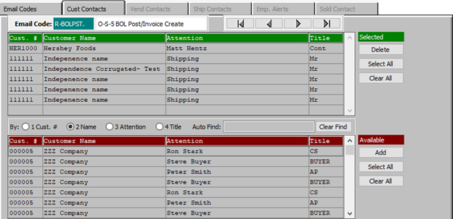

Adding contacts has many ways to search for specific customers or contacts by customer, title, name or attention.

#### DELETE (Selected)

To delete the currently selected Email Code, simply press the ***"D"*** key. Alternatively, click the ***“Delete”*** button at the bottom of the screen.

#### SELECT ALL (Selected)

Click the ***“Select All”*** button in the ‘*Selected’* section to highlight all Customer Contacts that are currently in the *‘Selected’* section. The user may use this for mass deletion of items within this section, as opposed to deleting contacts individually.

#### CLEAR ALL (Selected)

Click the ***“Clear All”*** button in the ‘*Selected’* section to un-highlight all Customer Contacts that are currently in the *‘Selected’* section.

#### ADD (Available)

Click on the selected contact from the ‘*Available’* list to highlight it, then click the ***“Add”*** button to add the selected column to the ‘*Selected’* list.

#### SELECT ALL (Available)

Click the ***“Select All”*** button in the ‘*Available’* section to highlight all Customer Contacts that are currently in the *‘Available’* section. The user may use this for mass deletion of all items within this section, as opposed to deleting contacts individually.

#### CLEAR ALL (Available)

Click the ***“Clear All”*** button in the ‘*Available’* section to un-highlight all Customer Contacts that are currently in the *‘Available’* section.

## Bill of Lading Posting

When the Finished Good Item is Posted, the program automatically creates an email.

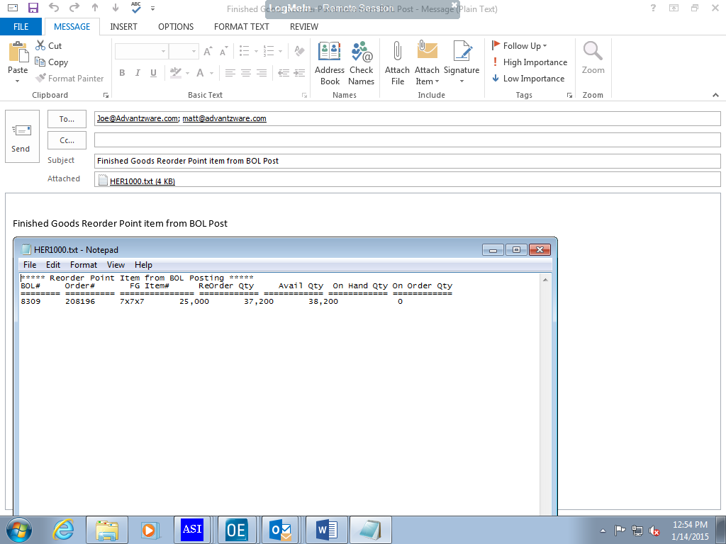

# **Employee Alert Help**

The Employee File in the Customer Maintenance File allows defining specific employees to be alerted via an automatic email when a specific program or action has occurred.

This allows different employees to receive an email when different activities occur. For example, when a customer places an order, specific employees will be sent an email automatically via Microsoft Outlook.

## Customer File Maintenance [AF1]

The *Customer File Maintenance* screen is located in the following Menu Path: Accounts Receivable -> File Maintenance for Customers -> Customers. Alternatively, the user can quickly get to this screen using the Hot Key combination: ***[“A” – “F” – “1”]***.



In order to view Employee information for a specific customer, the desired customer must be selected within the list of all available customers. The user may search for a specific customer, or narrow down the browse list, by using the search fields located along the top of the page.

In order to select a specific customer within the list to view detailed Employee information for, the user must ensure that it is highlighted within the list. In order to highlight a customer, the user may click on their desired customer.

## Employee Alert Information

To send out email notifications to internal users and employees when customers, salespeople, or external users add orders, request quotes, request estimates, etc. via the Advantzware software.

To view employee alert information for the selected customer, the user may now click on the ***“Two People”*** icon at the top of the screen.



### Browse Employee Alerts

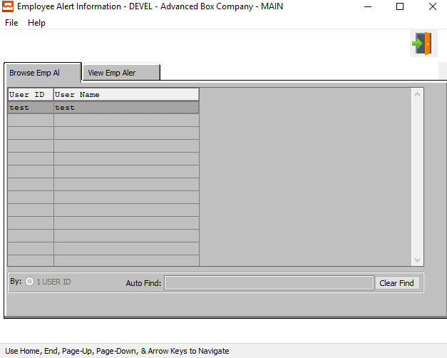

The Browse Employee Alerts screen will show the user all of the available Employees for the selected customer.

In order to view detailed information for a specific Employee, the desired Employee must be selected within the list of all available Employees. The user may search for a specific Employee, or narrow down the browse list, by using the search field located at the bottom of the page.

In order to select a specific Employee within the list to view detailed information for, the user must ensure that it is highlighted within the list. In order to highlight a Employee, the user may click on their desired Employee.

### View Employee Alerts

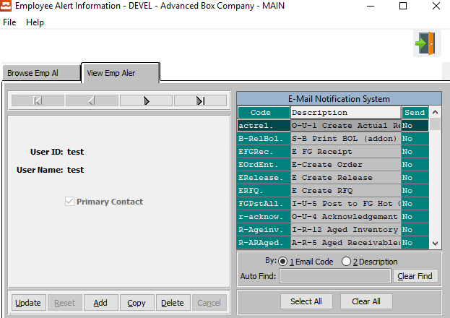

The ***“View Employee Alert”*** screen shows the user detailed information about the selected employee. In this screen, the user can update information about the current employee, update the current employee’s selected email notifications, or add a new employee.

#### UPDATE

Click the ***“Update”*** button to update the current employee’s information.

#### ADD

Click the ***“Add”*** button to add a new employee.

#### COPY

Click the ***“Copy”*** button to copy information from the currently selected employee.

#### DELETE

Click the ***“Delete”*** button to delete the currently selected employee.

#### NEXT

Press ***"N"*** (Next) to find next employee to view or modify. Alternatively, press the ***“Right Arrow”*** on the screen.

#### PREVIOUS

Press ***"P"*** (Previous) to find previous employee to view or modify. Alternatively, press the ***“Left Arrow”*** on the screen.

### Add/Update Employee Alert

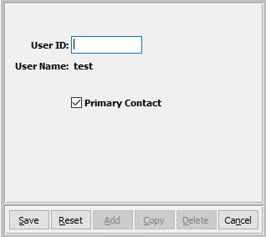

#### SAVE

Click the “***Save***” button to save the current Employee.

#### RESET

Click the “***Reset***” button to reset all changes to the Employee.

#### CANCEL

Click the “***Cancel***” button to cancel the Employee without saving changes.

#### User ID

Enter the User ID number for the desired employee.

#### Primary Contact – Toggle Box

To mark the current employee as the primary contact for this customer, make sure that this toggle box has been checked.

### Email Notification System Options



The *‘E-Mail Notification System’* allows the user to quickly choose which e-mails this Contact will receive from the Advantzware system. Contacts will only receive system emails that have their *“Send”* column set to ***“Yes”***.

In order to set the Contact up for a specific email notification, the user can search for their desired Email Code narrow down the browse list, by using the search field located at the bottom of the page.

In order to set a specific contact within the list to a ***“Yes”*** send option, the user must double-click the desired email code. This will set the email send option to ***“Yes”*** if it is currently ***“No”***, opting the Contact in for this specific email. Alternatively, double-clicking an email that currently has a send option of ***“Yes”*** will set it to ***“No”***, thus opting the contact out of receiving the selected email.

#### SELECT ALL

Clicking the ***“Select All”*** button will opt the user into receiving all the system emails currently available, setting all the Send Options to ***“Yes”***.

#### CLEAR ALL

Clicking the ***“Clear All”*** button will opt the user out of receiving all the system emails currently available, setting all the Send Options to ***“No”***.